

**Recipient: Trainees - 2023**

**Company:** Tatvasoft

**Version**: 1.0

**Date**: 28-08-2022

**Scope Document for**

**CI Platform**

TatvaSoft House, Rajpath Club Road, Near Shivalik Business Center, Opp. Golf Academy, Off S G Road, Ahmedabad - 380054, Gujarat, **India**

**TatvaSoft**

**Center**

**PROPRIETARY AND CONFIDENTIAL**

This document is a proprietary material of TATVASOFT prepared for its prospective client. By having access to this document, you agree to maintain strict confidentiality regarding its content. Disclosure of the same to any person/agency, whom TATVASOFT would deem to be its competitor, would be considered a violation of confidentiality.

**Scope Document**

Contents

[Introduction 4](#__RefHeading__339_1951240735)

[Platform login page](#__RefHeading__341_1951240735) 5

[Login………………..](#__RefHeading__343_1951240735) 5

[Forgot Password](#__RefHeading__345_1951240735) 6

[Reset Password](#__RefHeading__347_1951240735) 7

Registration 8

[Platform Landing Page](#__RefHeading__349_1951240735) 9

[Top header](#__RefHeading__351_1951240735) 9

[Search and filter missions 1](#__RefHeading__353_1951240735)0

[Mission listing](#__RefHeading__355_1951240735) 11

[Grid view………………………………………………………………………………………………………………………1](#__RefHeading__357_1951240735)1

[List view……………………………………………………………………………………………………………………….](#__RefHeading__359_1951240735)13

[Volunteering Mission Page 1](#__RefHeading__361_1951240735)5

[Related missions 2](#__RefHeading__363_1951240735)2

[Volunteering Story 2](#__RefHeading__365_1951240735)3

[Story listing page 2](#__RefHeading__367_1951240735)3

[Share your story (Add/Edit story detail) 2](#__RefHeading__369_1951240735)5

[Story detail page 2](#__RefHeading__371_1951240735)8

Volunteering Timesheet………………………………………………………………….29

[User edit profile](#__RefHeading__407_1951240735) 34

[Change Password](#__RefHeading__409_1951240735) 37

[Add Skills](#__RefHeading__411_1951240735) 39

[Policy Pages](#__RefHeading__413_1951240735) 41

[Contact us](#__RefHeading__415_1951240735) 43

[Footer Pages……………………………………………………………………………..](#__RefHeading__417_1951240735).45

Admin Screen…………………………………………………………………………….46

# Introduction

The platform will allow the company to “plan and manage effort that seeks to motivate and enable employees to effectively serve community needs through the leadership of the employer.”

**CI (Community investment / corporate social investment / Community social investment) platform** can also be called employee volunteer program, workplace volunteer programs, corporate volunteer programs, company volunteer programs, and other iterations. These programs are typically built to support a company’s larger corporate social responsibility program (CSR) or community engagement program or community investment program. Companies may have specific reasoning for building such platforms like building a positive brand reputation or increasing employee engagement in the community.

# Platform login page

Description:

This page will appear when user lands on the platform. This page will have banner at left side and login section at right side.

## Login

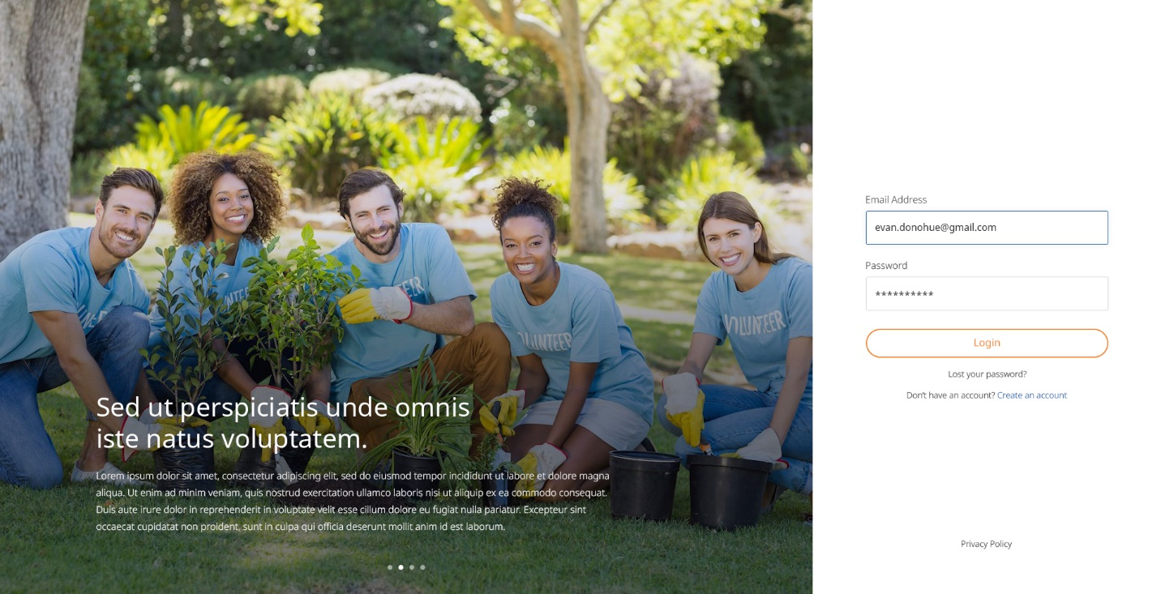Description:

User can login to platform using their email address and password.

Features:

|  |  |  |  |
| --- | --- | --- | --- |
| **#** | **Feature** | **Type** | **Description** |
|  | Email address | Input | User will need to enter his email address in this text box. |
|  | Password | Input | User will need to enter his password in this text box. |
|  | Login | Button | After entering correct email address and password, clicking on this button will allow user to sign in to the platform. |
|  | Lost your password? | Link | If a user forgets his or her password, he or she must select “Lost your password?” |
|  | Create an account | Link | If User don’t have account he can create form given link. |
|  | Footer links | Link | It will display links to pages such as privacy page. |

## Forgot Password

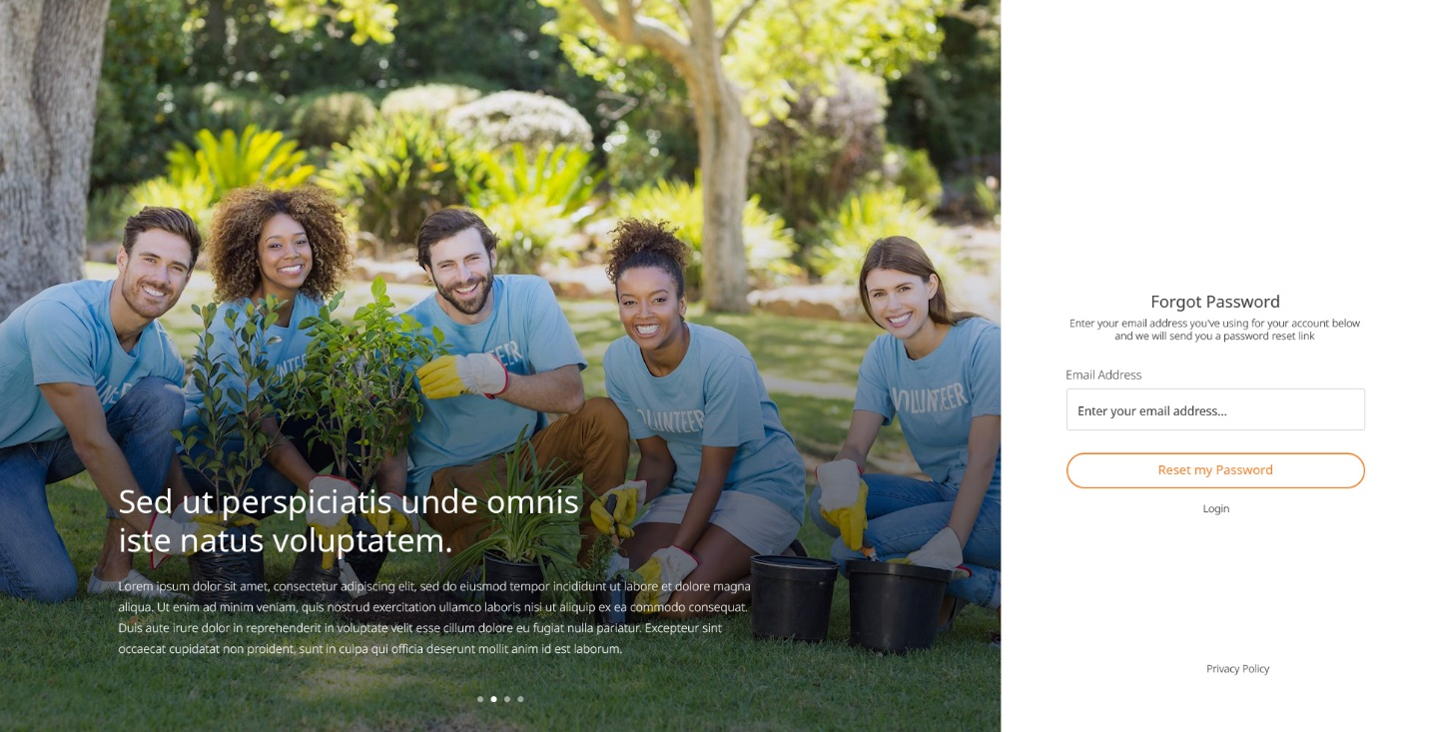

Description:

Users who have forgotten their password may request that it by entering their email address. System will check their email address existence, if it exists then reset password link will be sent to their email address. This link automatically expires after 4 hours or when it was already used to reset password successfully.

Features:

|  |  |  |  |
| --- | --- | --- | --- |
| **#** | **Feature** | **Type** | **Description** |
|  | Email address | Input | User will need to enter his email address in this text box. |
|  | Reset my password | Button | Clicking on this button, system will check if entered email address exists or not in platform. If it exists then Reset Password link will be sent to this email address. |
|  | Login | Link | Clicking on this link will redirect user back to login page. |

## Reset Password

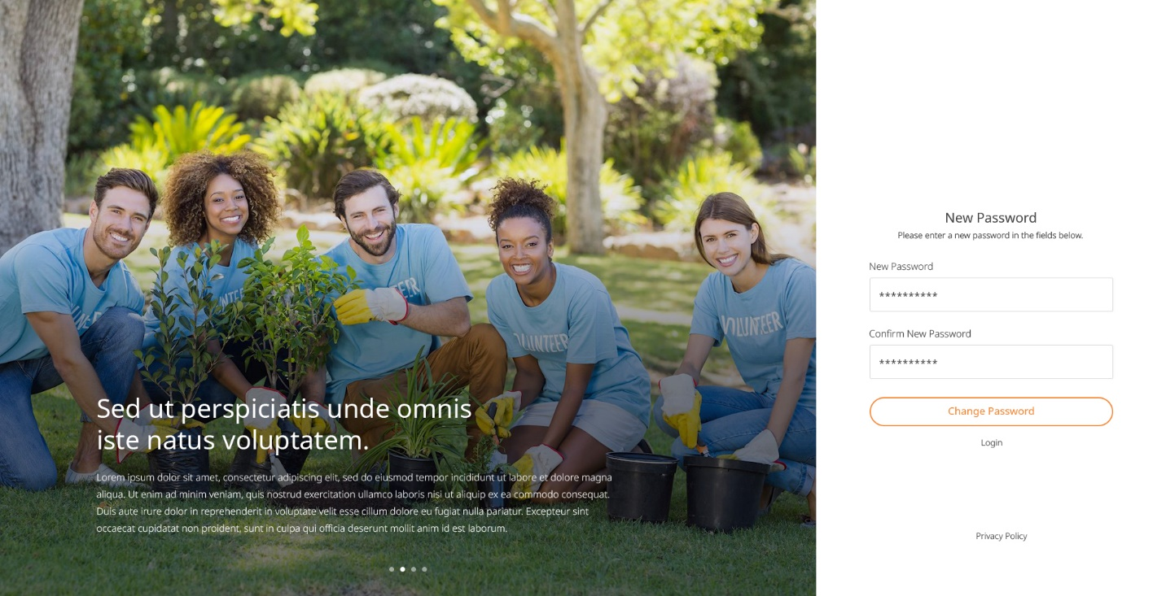

Description:

When clicking on reset password link from email, user will land to this page. Here user can reset his password by entering new password.

Features:

|  |  |  |  |
| --- | --- | --- | --- |
| **#** | **Feature** | **Type** | **Description** |
|  | New password | Input | User can enter new password using this input box. |
|  | Confirm password | Input | User will need to enter new password again in this input box. New password and Confirm Password must match. |
|  | Change password | Button | Clicking on this button, system will reset password for user. |
|  | Login | link | Clicking on this link will redirect user back to login page. |

## Registration

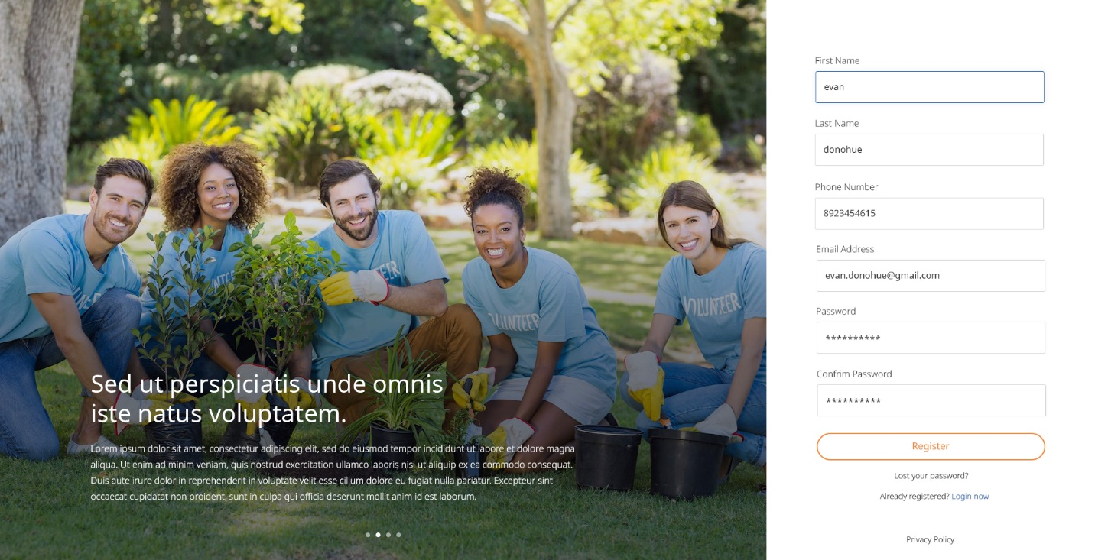

Features:

|  |  |  |  |
| --- | --- | --- | --- |
| **#** | **Feature** | **Type** | **Description** |
|  | First Name | Input | User will need to enter his First name in this text box. |
|  | Last Name | Input | User will need to enter his last name in this text box. |
|  | Email address | Input | User will need to enter his email address in this text box. |  |  |  |
|  | Phone Number | Input | User will need to enter his Phone number in this text box. |  |  |  |
|  | Password | Input | User will need to enter his password in this text box. |  |  |  |
|  | Confirm Password | Input | User will need to enter same password as above in this text box. |
|  | Register | Input | User will Click button for new registration. |  |  |  |

# Platform Landing Page

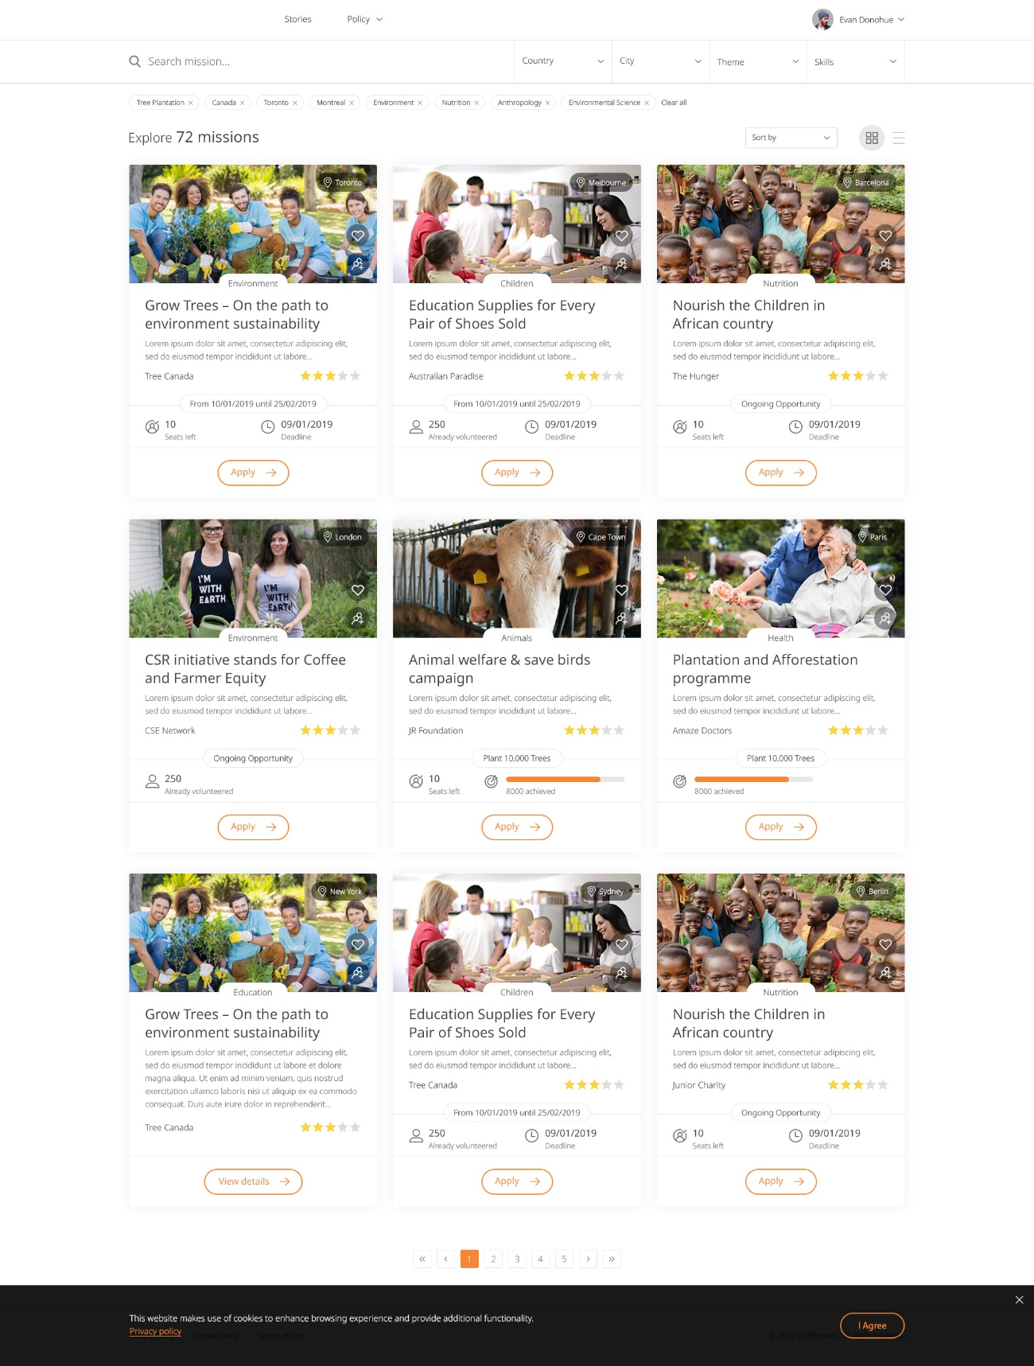

Description:

After successful login, user will be redirected to platform landing page. This page will display missions. User can filter missions by theme and skills. User can also search missions by mission title, mission description. User can view missions either by grid view or list view.

From Admin: Any CMS page will be added, will display under “Policy” dropdown menu.

**Top header**



Features:

|  |  |  |  |
| --- | --- | --- | --- |
| **#** | **Feature** | **Type** | **Description** |
|  | Stories | Link | Clicking on this link, user will be redirected to story listing page. |
|  | Policy | Drop-down | It will list all policy pages added by admin |
|  | User pages | Drop-down | By clicking on user avatar or name, it will list available pages such as My Profile, Volunteering Timesheet and Logout link. |

## Search and filter missions



Description:

User will be able to quickly search by country then city then by theme then by skills. User can also search missions by specific keywords.

Features:

|  |  |  |  |
| --- | --- | --- | --- |
| **#** | **Feature** | **Type** | **Description** |
|  | Search mission | Input | User can search missions by mission title, description |
|  | Quick access filter: Theme | Drop-down | It will display themes available in the platform, that contains >=1 mission. |
|  | Quick access filter: Skill | Drop-down | It will display skills available in the platform, that contains >=1 mission. |

## Mission listing

### Grid view

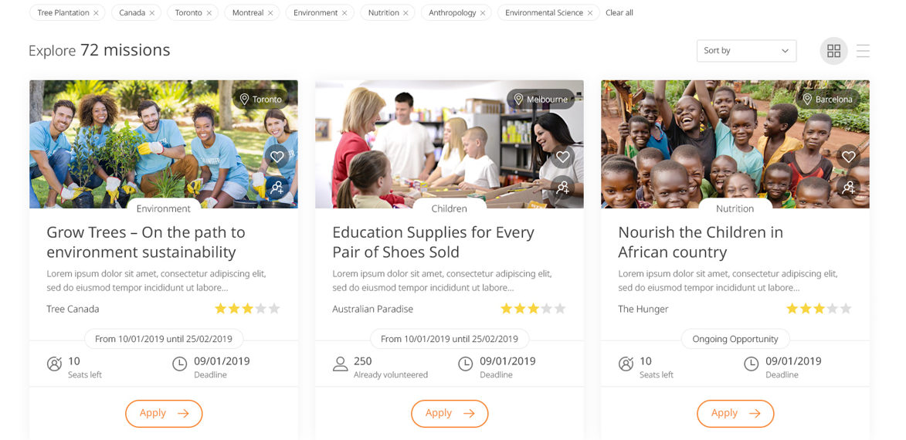

Description:

There are two types of missions available in this platform. 1. **Time Mission** 2. **Goal Mission**

It will list time and goal missions in grid view by default.

By default, it will show missions as per user's country and city.

Features:

|  |  |  |
| --- | --- | --- |
| **#** | **Feature** | **Description** |
|  | Filter tags | By default it will use user's country and city as tags. User can remove city tag by clicking on cross(X) icon. User can't remove country from filter tag.  Any filters selected from quick access filters will displayed here as tag. |
|  | Clear all | User can remove all selected filters by clicking on this link. |
|  | Sorting missions | Below options are available to sort missions:   * Newest – It will show latest missions first. * Oldest – It will show oldest missions first. * Lowest available seats – It will show missions which have least seats available. * Highest available seats – It will show missions which have highest seats available. * My favourites – It will sort missions by logged in user's favourites * Registration deadline – It will sort missions by their application deadline |
|  | Mission grid view | It will display missions in grid view. |
|  | Mission list view | It will display missions in list view. |
|  | Applied / Closed tag | If user has applied to a mission, then it will show tag as “**Applied**”.  For Time mission – If application deadline or mission end date is passed then it will show tag as “**Closed**”. |
|  | Mission thumbnail | It will show first image of mission media as thumbnail. |
|  | Mission location | It will show city of mission. |
|  | Add to favourites | By clicking on this icon, mission will be added to Favourites |
|  | Invite colleague | By clicking on this icon, user can share or invite to apply for this mission to his colleague or co-worker. |
|  | Mission theme | It will show mission theme. |
|  | Mission title | Displays mission title. |
|  | Short description | It will display mission's short description. |
|  | Organisation | Displays mission organisation. |
|  | Rating | It will show average ratings for a mission. |
|  | Goal object | For **Goal Mission –** It will display objective of a goal mission. |
|  | Seats left | It will show count of seats left for the mission. |
|  | Achieved goals | For **Goal Mission** – Display a line progress chart that display current status vs goal |
|  | View Detail button | “View Detail” button will be displayed for below cases:   * When user has already applied for a mission * If mission's application deadline is passed * If mission is closed or mission's end date is passed * If all seats are taken |
|  | Mission dates | For **Time Mission –** It will show mission start date and end date. |
|  | Mission application deadline | For **Time Mission** – It will show mission's application deadline. |
|  | Apply button | By clicking on this button, user can apply for a mission. |

### List view

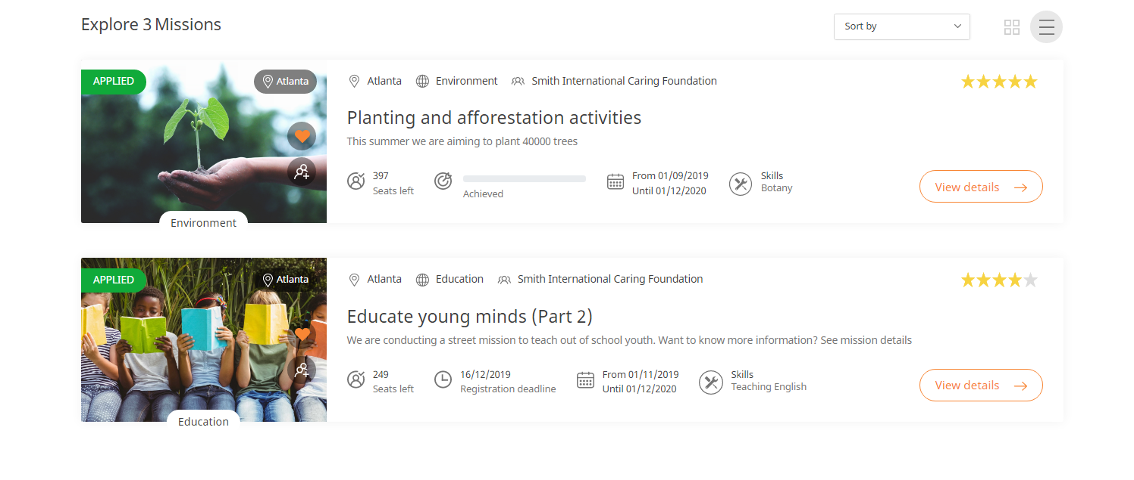If there is no any mission found then it will show empty page as below with Submit new mission button. This button will only show if its enabled by a tenant.

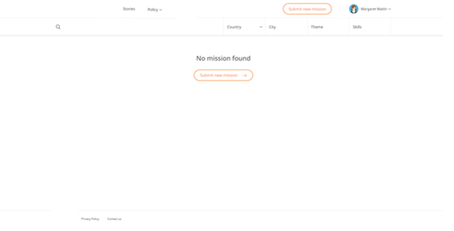

Volunteering Mission Page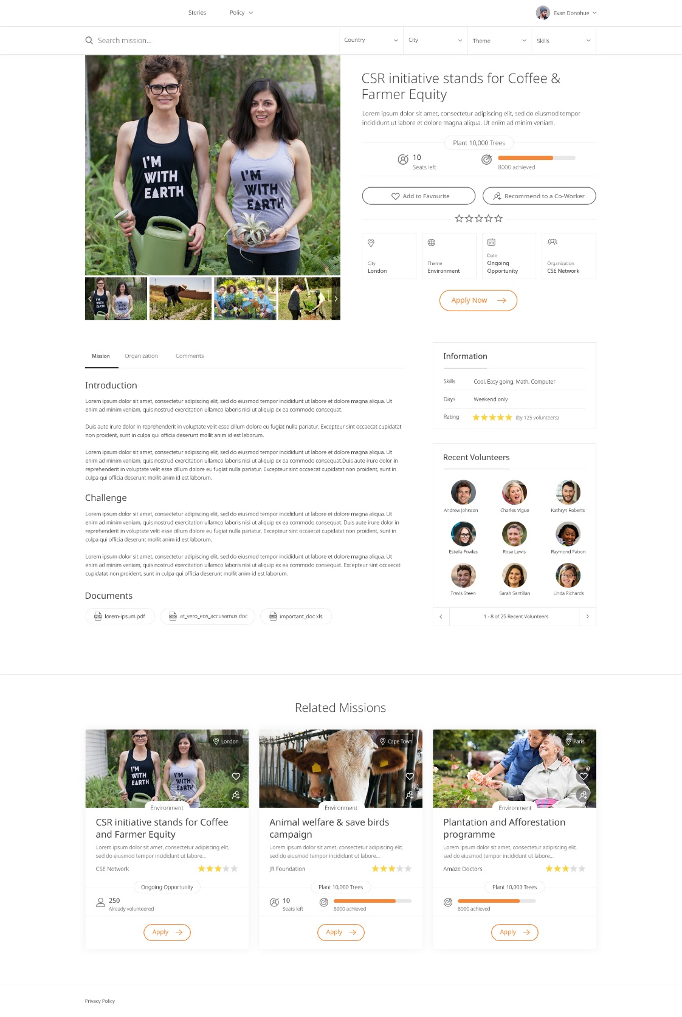

Description:

This page will display mission details before user can apply to the mission.

By default, it will display mission detail.

Below are types of missions:

* Time Mission: If mission is of type “Time” then show start date and end date
* Goal Mission: If mission is of type “Goal” then show Goal objective

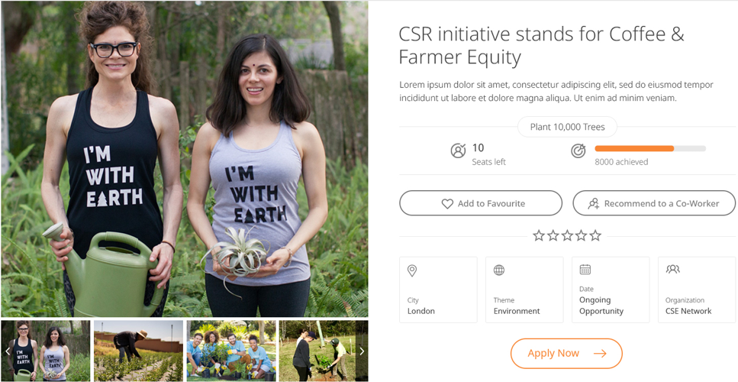

Features:

|  |  |  |
| --- | --- | --- |
| **#** | **Feature** | **Description** |
|  | Mission title | It will display mission's title. |
|  | Ratings | It will gives ability to a user to rate a mission between 1-5 stars. |
|  | Add to favourites | User can add a mission to his favourites list |
|  | Short description | It will show mission's short description |
|  | Mission dates | It will show mission's start and end date |
|  | Seats | It will show remaining seats for a mission |
|  | Application deadline | It will show mission application deadline. If deadline is passed, then user can't apply to a mission. |
|  | City | Mission city |
|  | Theme | Mission theme |
|  | Start date | Mission start date |
|  | Organisation | Mission's organisation |
|  | Recommend to co-worker | User can recommend or invite his colleague to apply for this mission. |
|  | Apply | User can apply to a mission by clicking on this button. |
|  | Mission media | It will show mission media images and videos. |
|  | Media carousel | It will list media image thumbnails in carousel. |

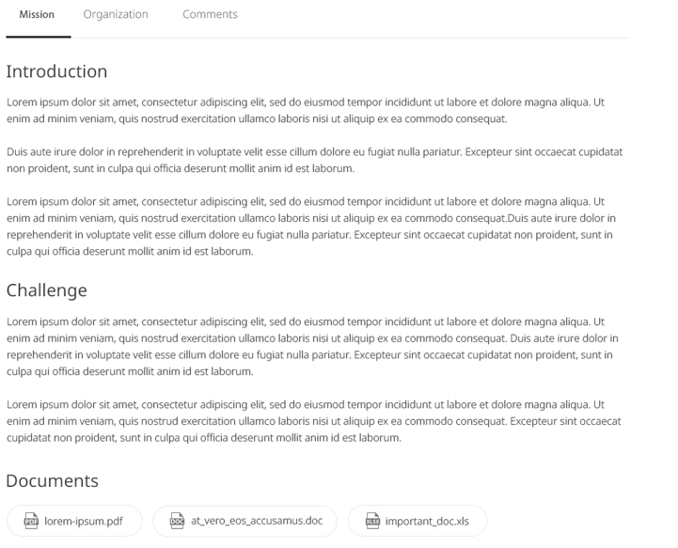

Features:

|  |  |  |
| --- | --- | --- |
| **#** | **Feature** | **Description** |
|  | Mission tab | It will show mission description in this tab. |
|  | Organisation tab | It will show organisation detail in this tab. |
|  | Comments tab | User can view comments from other users on this mission. User can also post comment on a mission. |
|  | Documents | It will show mission related documents. It will open document in new tab. |

**Organisation Tab:**

**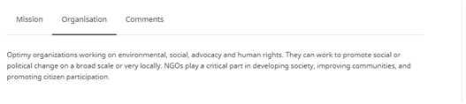**

|  |  |  |
| --- | --- | --- |
| 5.8.1 | Organisation detail | It will display organisation details. |

**Comments Tab:**

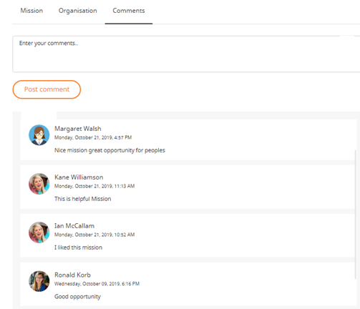

Features:

|  |  |  |  |
| --- | --- | --- | --- |
| **#** | **Feature** | **Type** | **Description** |
|  | Enter comments | Text-area | User can write comments using this text-area. Maximum 600 characters are allowed. |
|  | Post comment | Button | By clicking on this button, comment will be posted for a mission. It will be published automatically and display to other users if tenant has this setting enabled. |
|  | Past comments | List | It will list posted comments on this mission. |

**Information section:**

**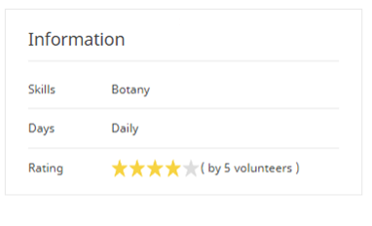**

|  |  |  |
| --- | --- | --- |
|  | Information | This section will show mission information such as:  - Skills - Days: Mission's availability i.e. Daily, Weekly, Week-end etc. - Rating: It will show average ratings for this mission. |

**Recent Volunteers:**

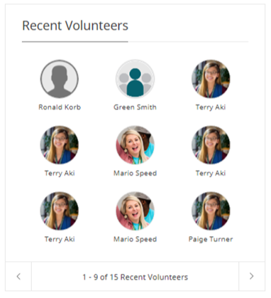

|  |  |  |
| --- | --- | --- |
|  | Recent Volunteers | It will show volunteers who have successfully applied for this mission. |

## Related missions

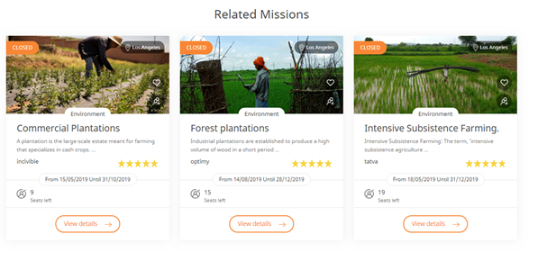

Features:

|  |  |  |
| --- | --- | --- |
| **#** | **Feature** | **Description** |
| 5.23 | Related mission | It will display maximum 3 missions.  It will fetch missions which are in same city as current mission.  If no mission found for same city, it will return missions which are in same country as current mission.  If no mission found for same country, it will return mission which has same theme as current mission. |

# Volunteering Story

## Story listing page

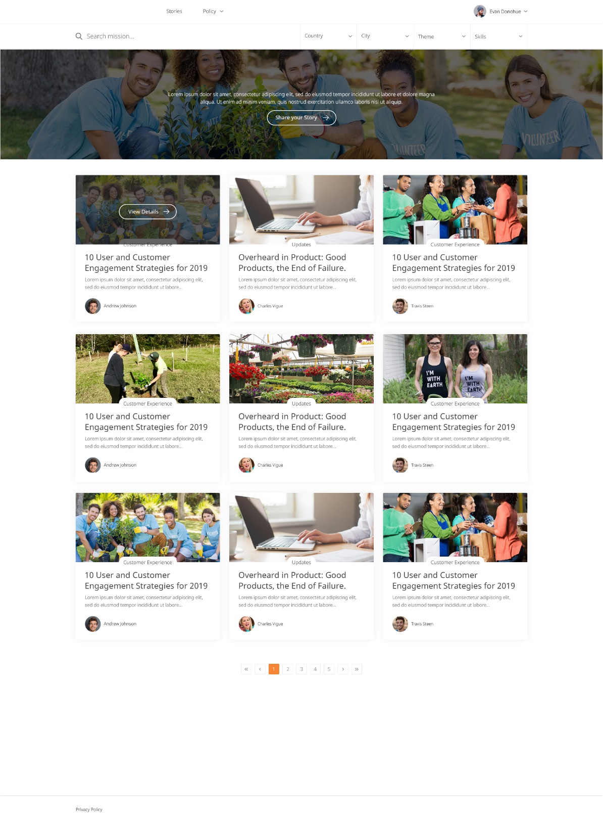

Description:

This feature allows users to view and submit stories about their experience as volunteers.

Features:

|  |  |  |  |
| --- | --- | --- | --- |
| **#** | **Feature** | **Type** | **Description** |
|  | Share your story | Button | Clicking on this button will redirect user to add/edit story page. |
|  | Story thumbnail | Image | Story thumbnail picture |
|  | Mission theme | Text | Mission theme of a mission for which user has submitted a story |
|  | Story title | Text | Story title |
|  | Story description | Text | Short description of a story. Maximum 150 characters will be displayed. |
|  | User | Text | It will show user avatar and user's name who have published story |
|  | Published date | Date | It will display published date when this story is published. Format: dd/mm/yyyy |

## Share your story (Add/Edit story detail)

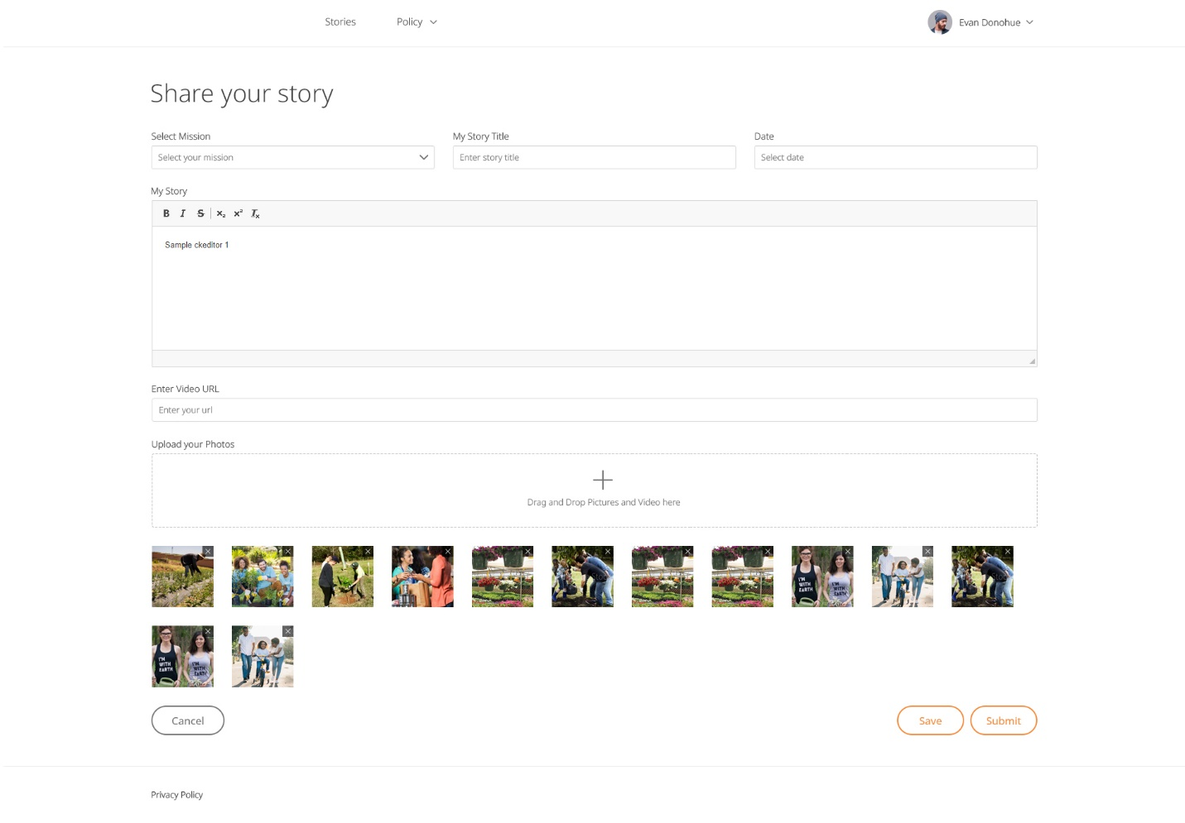  
Description:

User can submit his or her story from this page. User must have applied to a mission and mission application must be approved when submitting a story. Because mission selection is required when creating a story.

When user saves story detail, it will be saved as a 'Draft'. User can only preview story details in 'Draft' mode. Then story will published on platform, it will appear on platform and other user can view it.

Features:

|  |  |  |  |
| --- | --- | --- | --- |
| **#** | **Feature** | **Type** | **Description** |
|  | Story title | Input | Add story title from this text box.  Maximum 255 characters are allowed. |
|  | Select mission | Drop-down | It will have missions as options for which user has volunteered. |
|  | My Story | Editor | Story description can be added from here.  Maximum 40000 characters are allowed. |
|  | Enter video URL | Text-area | User can add video URL for story in this text-area.  Only YouTube URL is allowed. Use new line to add multiple video URLs. Maximum 20 URLs can be added. |
|  | Upload story photo | File | User can drag n drop or upload photos in this area. Only png, jpg and jpeg image types are allowed. Maximum 20 images can be added. An image should not be greater than 4MB. Recommended size: 900 x 510 |
|  | Cancel | Button | When clicking on this button, user will be redirected to story listing page. |
|  | Preview | Button | User can preview story by clicking on this button. It will open story detail in new tab. User who has created story can preview only his story. |
|  | Save | Button | When clicking on this button, story detail will be saved as a 'Draft'. |
|  | Submit | Button | This button will be disabled initially. Once user saves story, it will be enabled. By clicking on this button, Story will be saved. |

## Story detail page

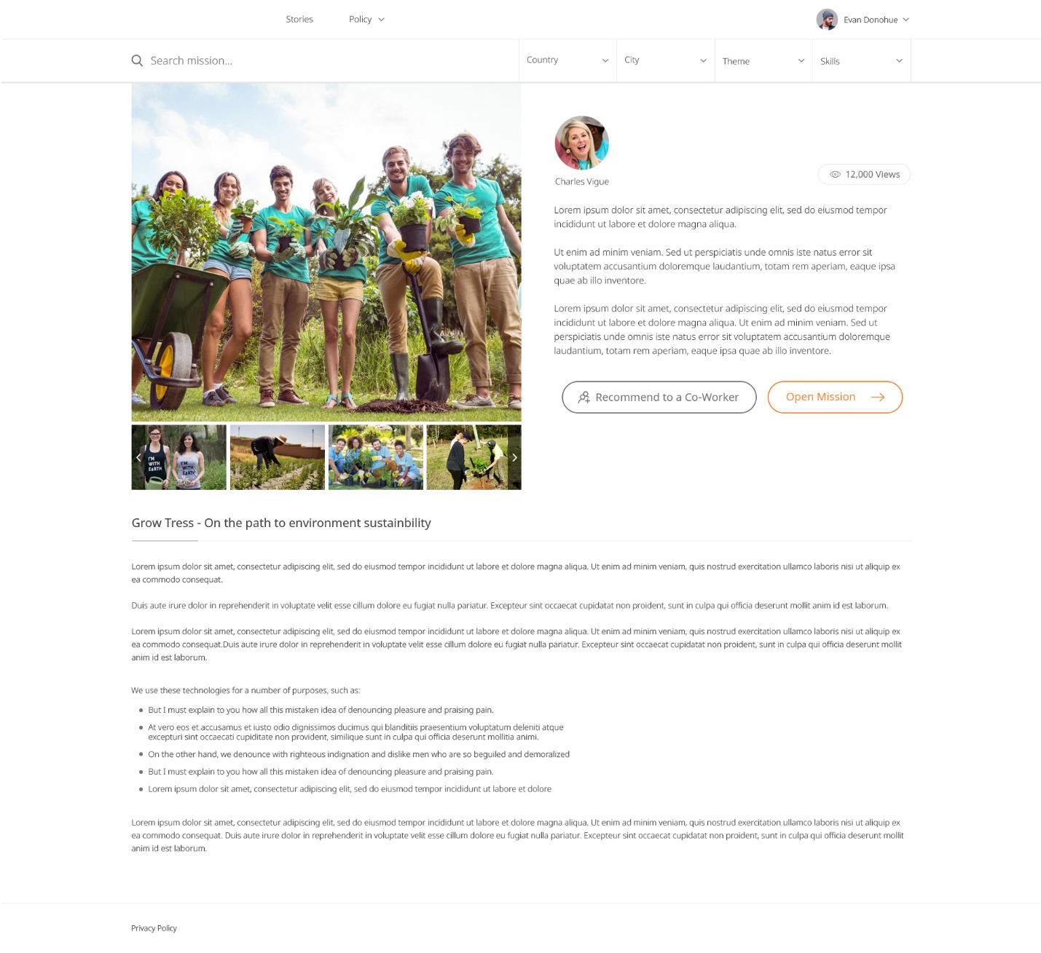

Description:

It will show details of a story. User can view story title, description, media and user detail by whom story is added. User can also recommend a story to a co-worker.

Features:

|  |  |  |  |
| --- | --- | --- | --- |
| **#** | **Feature** | **Type** | **Description** |
|  | Story title | Text | Title of the story |
|  | Views | Number | Display total views of a story. Views are counted each time it is viewed by a user in the platform. |
|  | Story media carousel | Image or video | It will contain image or embedded video from YouTube. User can click on a picture and the main image is replaced by selection. |
|  | Story user | text | It will display user detail who have created this story. It will show user's full name, avatar, city and country. |
|  | User introduction | text | It will show “Why I volunteer?” field value from user profile of the user who have created this story. |
|  | Story description | text | It will show story's description |
|  | Recommended to co-worker | Button | User can recommend this story to co-worker by clicking this button. User can search co-worker by name or email. |
|  | Open mission | Button | By clicking on this button, user will be redirected to a mission page for which this story is created. |

**Volunteering Timesheet**

**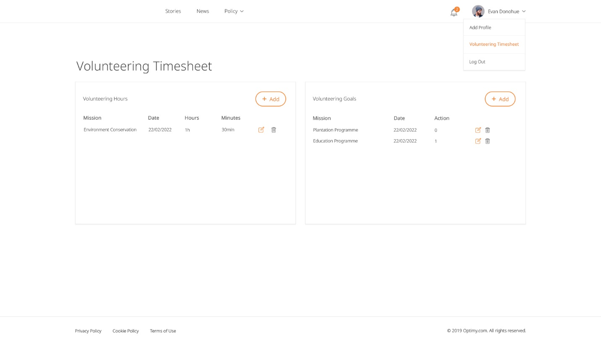**

Description:

In this page, user can log his volunteering time on a set date. While logging, user can leave a note. Clicking on my profile drop down volunteering Timesheet will open.

For **Goal Mission:** user can log his volunteering action on a set date.

**Volunteering Hours**

Features:

|  |  |  |
| --- | --- | --- |
| # | Feature | Description |
|  | Volunteering hours | In this section, user can filter time entries by input time on a mission |
|  | Time entry hours | Time entry added by user, and its not yet submitted for approval. That means user can still edit this time entry. |
|  | Add time entry | By clicking on Add Button, user can add time entry. |
|  | Volunteering goal | In volunteering goal timesheet user can filter by month/year and input action on a mission |
|  | Add volunteering action | By clicking on this icon user will get pop up to add volunteer action. |

Description:

In volunteering hours timesheet - user can filter timesheet entries by Date and Hours and add time entry on a mission.

User can add hour’s entry by clicking on '+' (Add) icon for a day.

User can't add time entry before mission's start date, after today's date and after mission's end date.

**Volunteering goals**

Description:

In volunteering goals timesheet - user can filter timesheet entries by Date and action on a mission.

User can add goal action by clicking on '+' (Add) icon.

User can't add action before mission's start date, after today's date and after mission's end date.

**Volunteering Hours Entry**

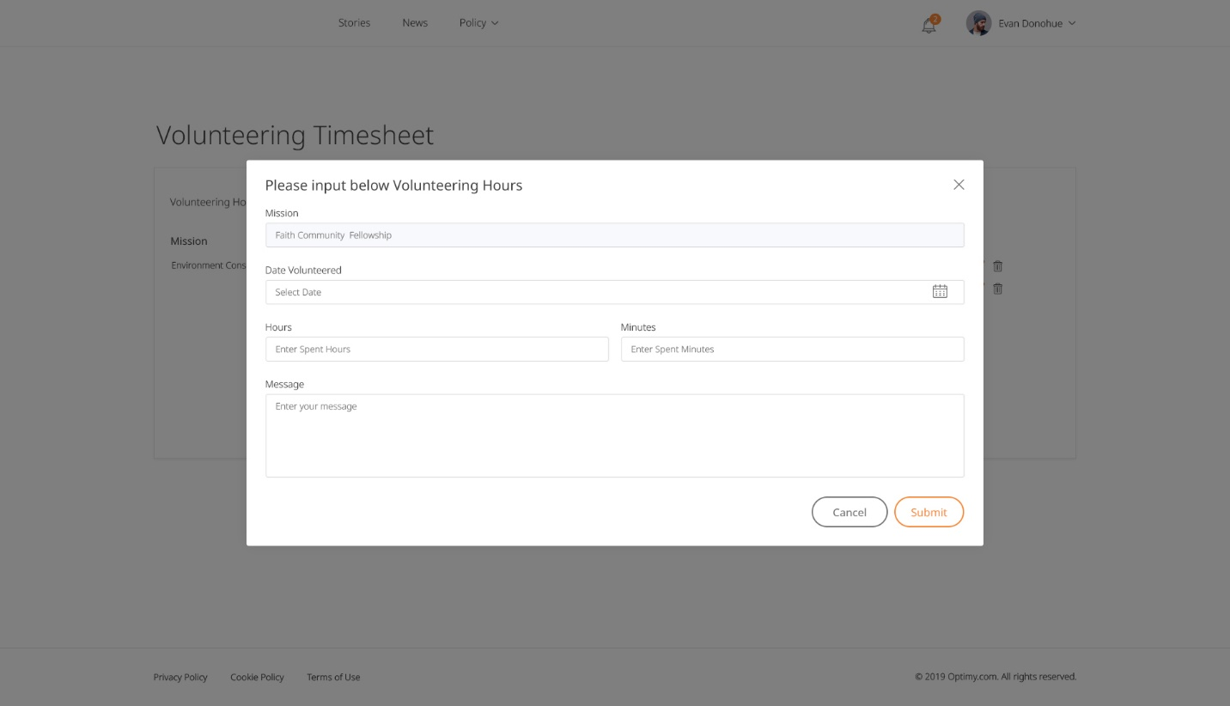

Description:

From volunteering hour entry modal, user can input the hours and minutes with dates and a note.

Features:

|  |  |  |  |
| --- | --- | --- | --- |
| **#** | **Feature** | **Type** | **Description** |
|  | Mission | Text | It will show mission for which user is adding volunteering hours. |
|  | Hours | Text box | User can add volunteering hours from this field. Its a required field and must be a number from 0 to 23. |
|  | Minutes | Text box | User can add volunteering minutes from this field.  Its a required field and must be a number from 0 to 59. |
|  | Date volunteered | Date picker | From this User can select date for which he wants to add volunteering hours.  It's required field and must be a date. |
|  | Notes | Text area | User can add notes regarding volunteering time entry. It's required field. |
|  | Cancel | Button | By clicking on this button, pop up will be closed without saving details and user will be redirected to volunteering timesheet page. |
|  | Submit | Button | By clicking on this button, user can save volunteering hours entry to timesheet. |

**Volunteering Goals Entry**

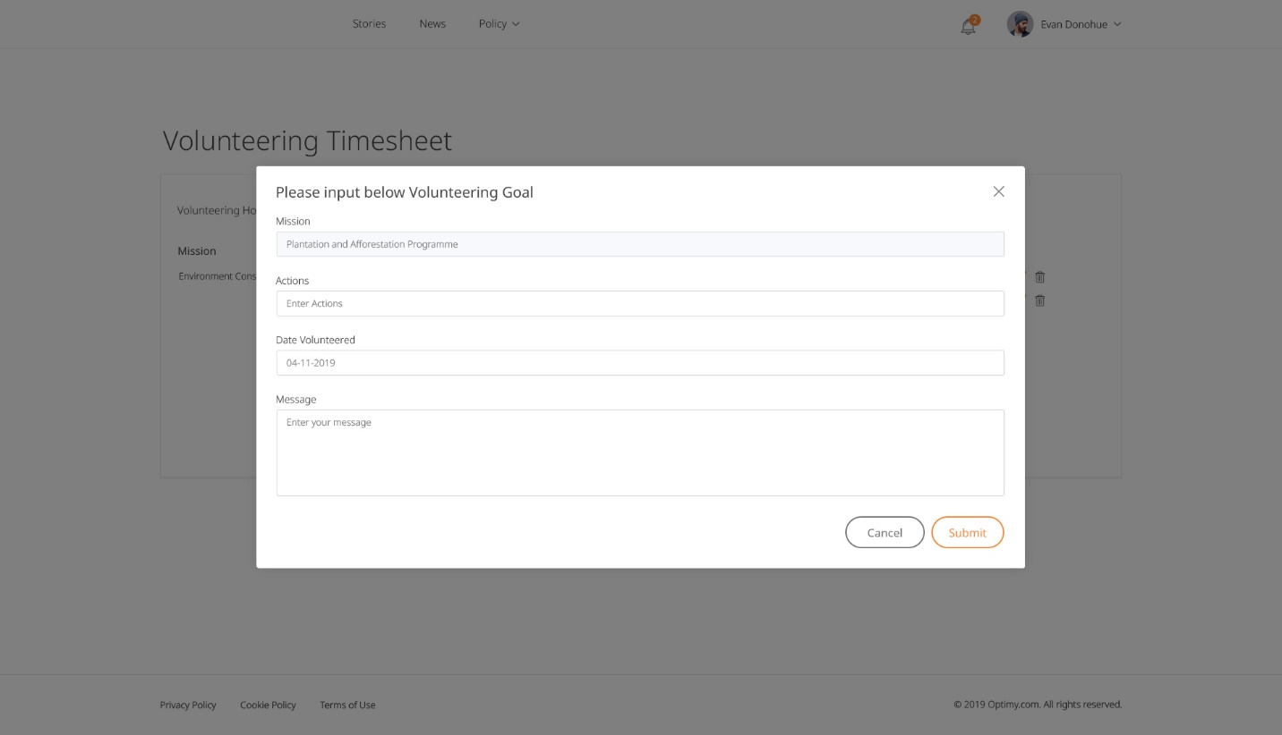

Features:

|  |  |  |  |
| --- | --- | --- | --- |
| **#** | **Feature** | **Type** | **Description** |
|  | Mission | Text | It will show mission for which user is adding volunteering hours. |
|  | Action | Text box | From this user can add volunteering action. It's required field and must be a number. |
|  | Date volunteered | Date picker | From this User can select date for which he wants to add volunteering goal action. It's required field. |
|  | Notes | Text area | User can add any notes regarding volunteering. It's required field |
|  | Cancel | Button | By clicking on this button pop up will be closed without saving details. user will redirected to volunteering timesheet page. |
|  | Submit | Button | By clicking on this button user can save volunteering goal entry to timesheet. |

# User edit profile

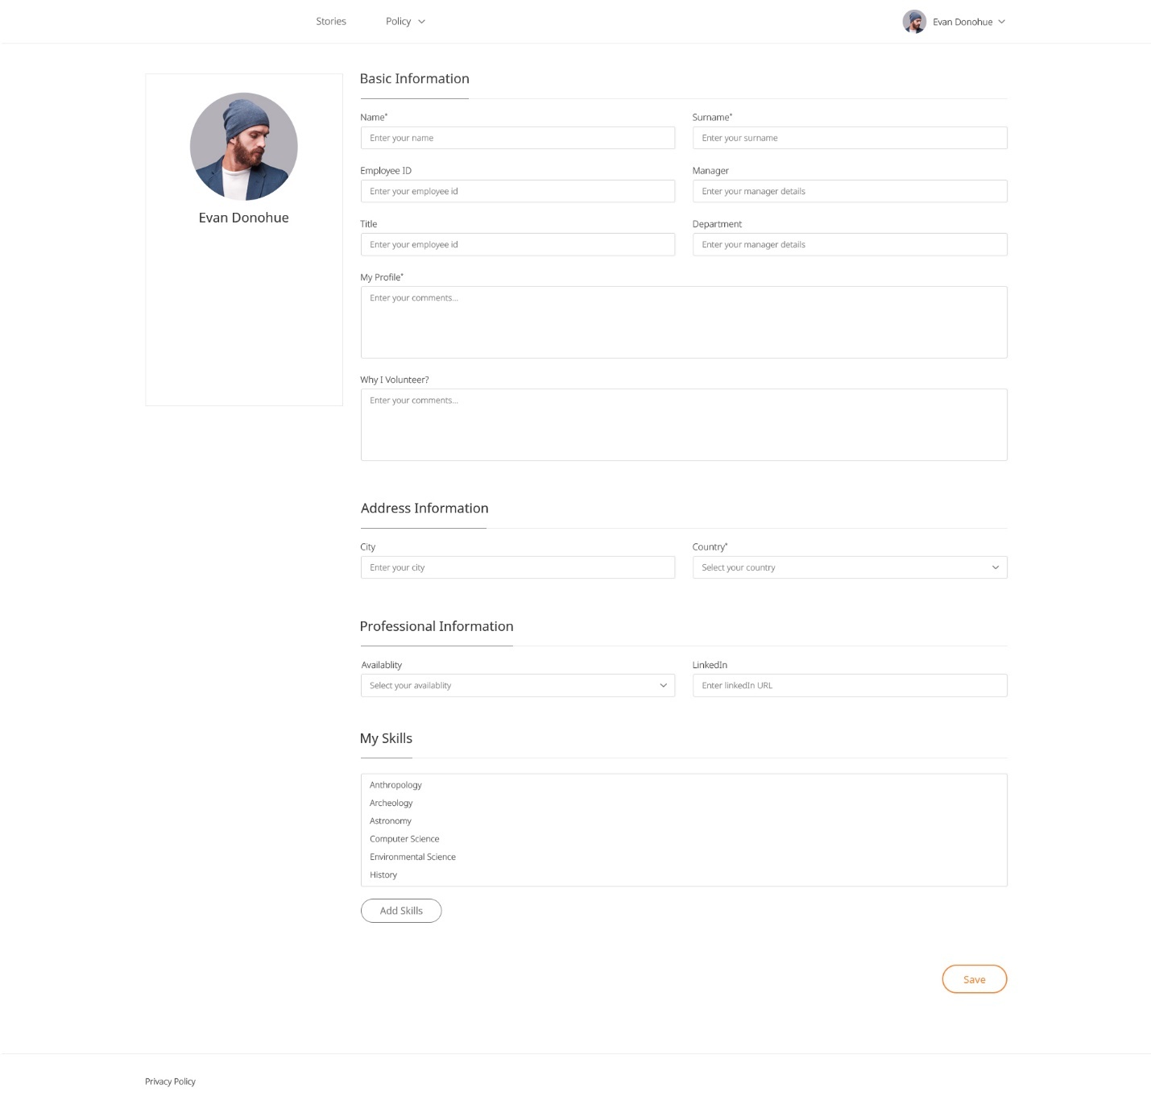

Description:

User can update his/her basic, address details and additional details, skills. User can also change their password.

Below fields are mandatory when updating user profile:

* Name
* Last name
* Country
* City

When user logs in and any of the above fields is empty, then his profile will be marked as “**Incomplete**” and hence will not be able to access any page of the platform.

Once the user will fill up these mandatory fields, he will be able to access the whole platform.

Features:

|  |  |  |  |
| --- | --- | --- | --- |
| **#** | **Feature** | **Type** | **Description** |
|  | User profile image | Image | It will show user profile image. User can also change profile image. Valid image types are png, jpg, jpeg. |
|  | Name | Text | It will show user's full name. |
|  | Change password | Button | It will open a popup to change password. |
|  | First name | Input | User can enter his first name in this input field.  Maximum 16 characters are allowed. |
|  | Surname | Input | User can enter his surname in this field.  Maximum 16 characters are allowed. |
|  | Employee ID | Input | User can enter his unique employee id in this field. Maximum 16 characters are allowed. Must be unique. |
|  | Title | Input | User can enter his title. Maximum 255 characters are allowed. |
|  | Department | Input | User can enter his department.  Maximum 16 characters are allowed. |
|  | Profile summary | Text-area | User can enter his profile short summary. |
|  | Why I volunteer | Text-area | User can enter information about reason for volunteer in this field. |
|  | Country | Drop-down | User can select his/her country from this list. |
|  | City | Drop-down | User can select city listed according to the selected country. |
|  | Availability | Drop-down | User can select availability. ie. Daily, Weekend etc |
|  | My skills | Lists | Selected skills are listed here. |
|  | Add skills | Button | User can add skill by clicking on this button. |
|  | Save | Button | User can save all entered details. |

## Change Password

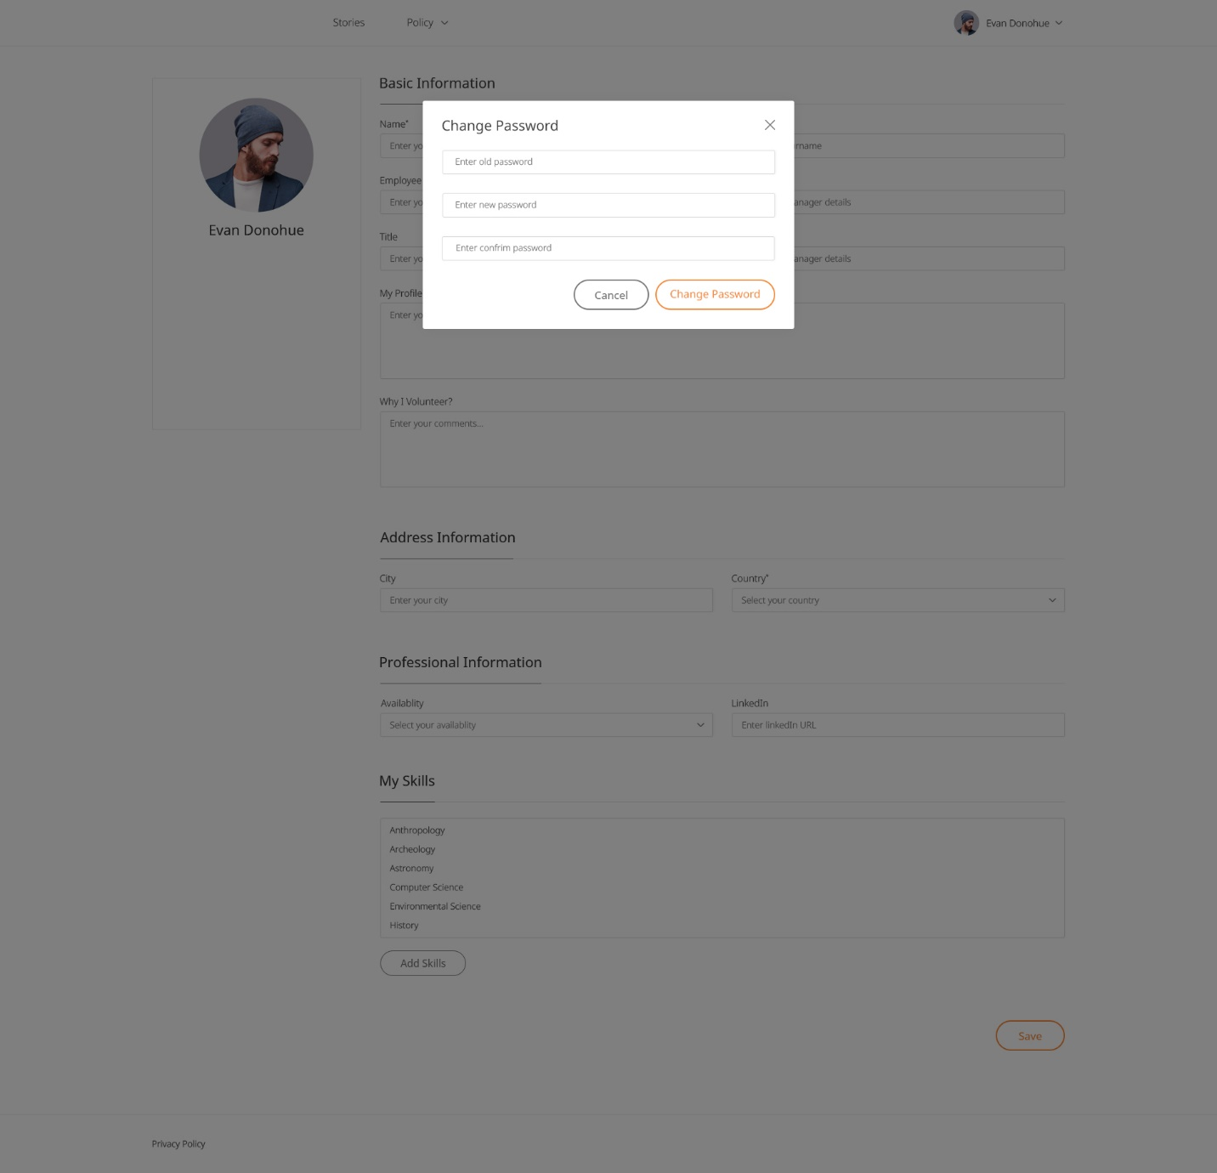

Description:

User can change his/her password form this popup.

Features:

|  |  |  |  |
| --- | --- | --- | --- |
| **#** | **Feature** | **Type** | **Description** |
|  | Old password | Input | User must enter old password in this field. |
|  | New password | Input | User will enter new password.  Minimum 8 characters are required. |
|  | Confirm password | Input | Confirm password must match to new password. |
|  | Cancel | Button | Close the popup for change password. |
|  | Change password | Button | Password will be changed clicking on this button |

## Add Skills

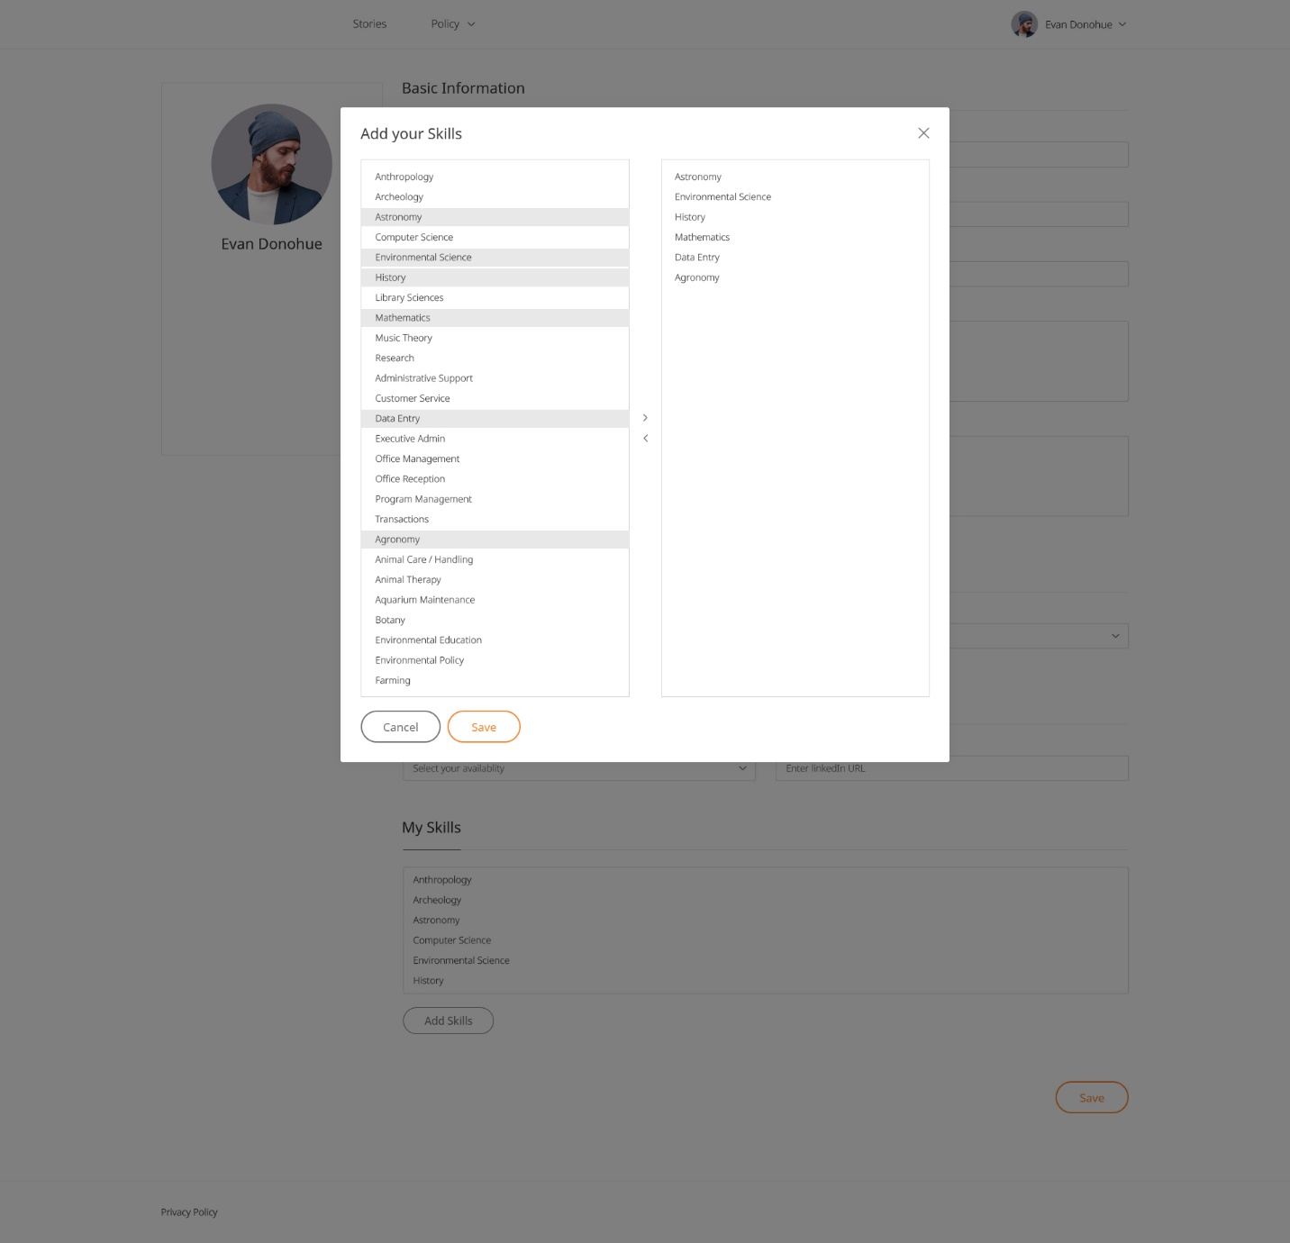

Description

User can add/remove skills from this popup.

Features:

|  |  |  |  |
| --- | --- | --- | --- |
| **#** | **Feature** | **Type** | **Description** |
|  | Close | icon | User can close popup by clicking on this icon. |
|  | Skill | List | It will display all skills. |
|  | Add Skill | icon | User can add skill by clicking on plus icon. |
|  | Added Skill | List | Added skill will be displayed in this list. |
|  | Remove Skill | icon | User can remove skill by clicking on this button. |
|  | Reset | Button | It will reset added skill list. |
|  | Save | Button | It will save selected skills. |

# Policy Pages

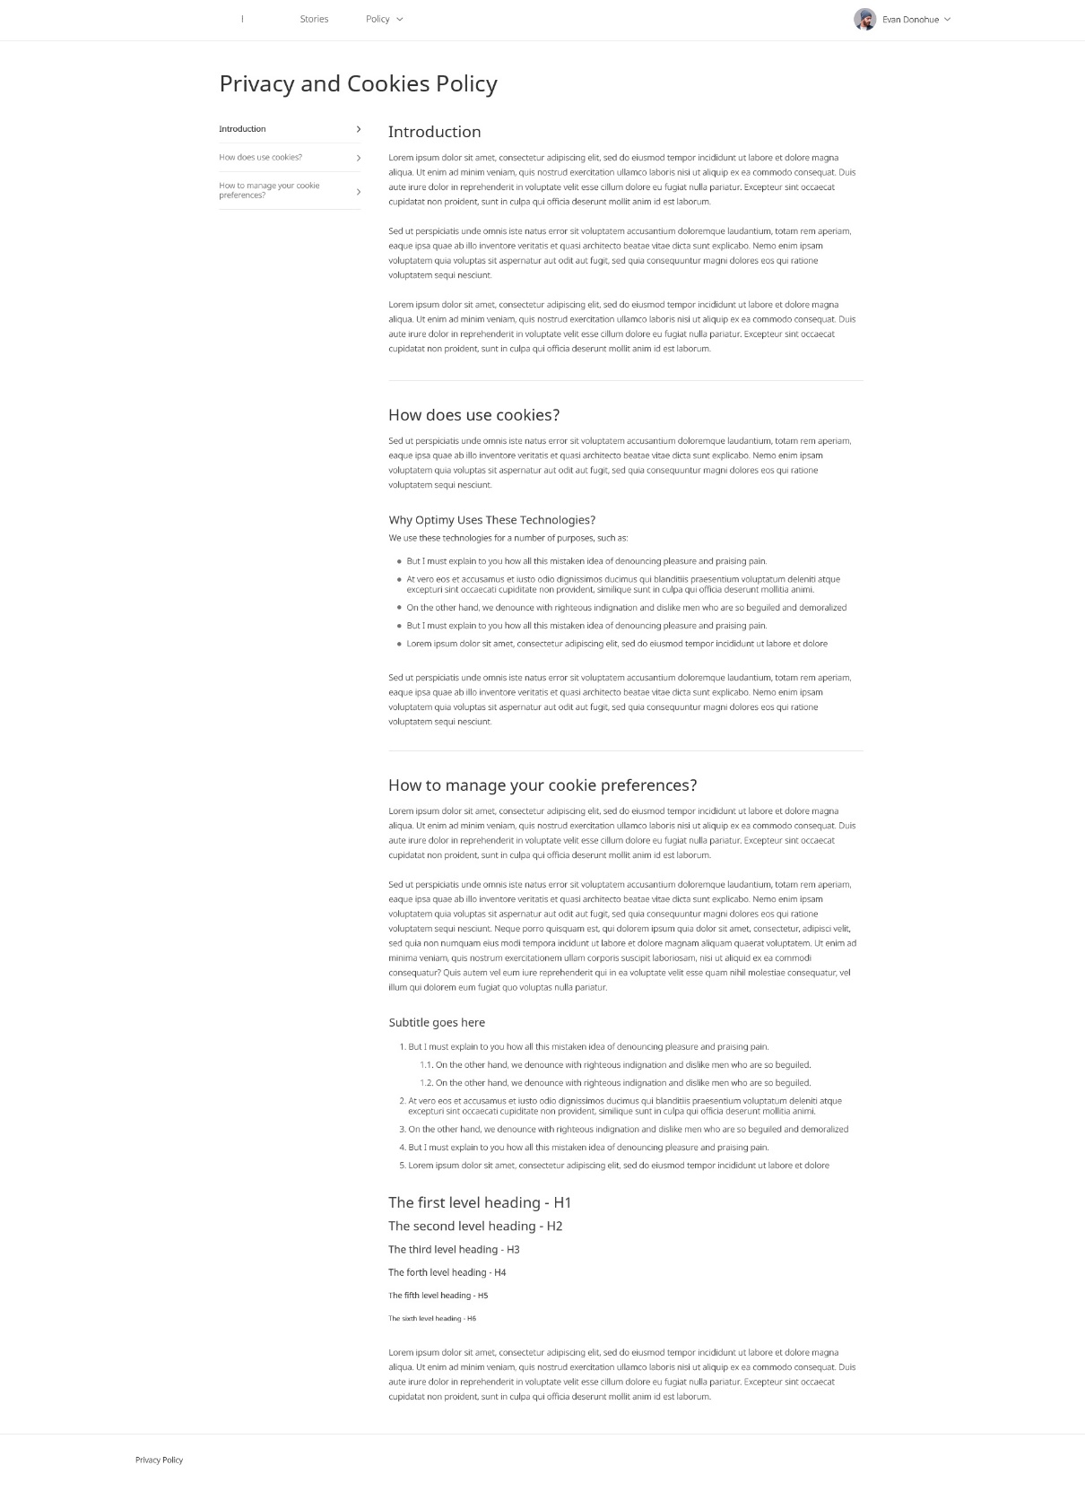

Description:

It will display company policy pages.

Features:

|  |  |  |
| --- | --- | --- |
| **#** | **Feature** | **Description** |
|  | Titles | It will show main titles on the page. Clicking on title will scroll to that section on right side. |

# Contact us

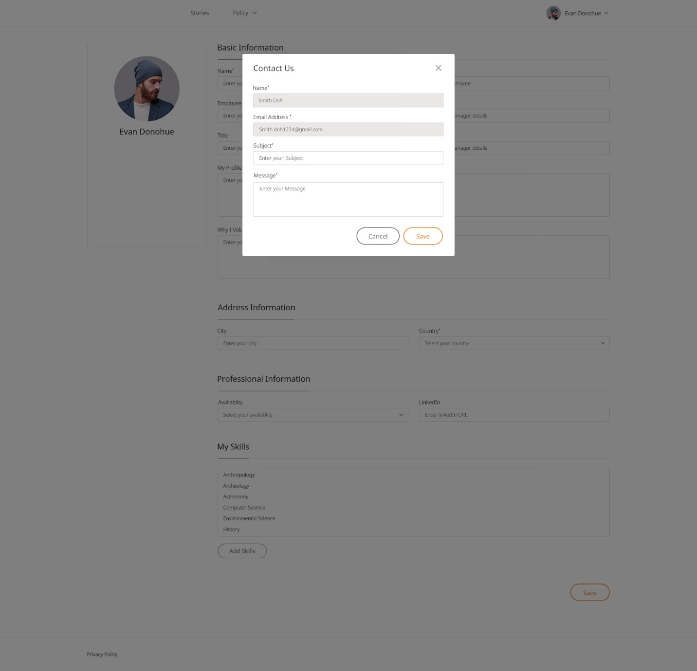

Description

A user can send any bugs, opinion, suggestion or query regarding system directly.

Features:

|  |  |  |  |
| --- | --- | --- | --- |
| **#** | **Feature** | **Type** | **Description** |
|  | Name | Text | It will display logged in user's full name. This field is read only. |
|  | Email address | Text | It will show the email address of user. This field is read only. |
|  | Subject | Input | User will enter subject regarding his query.  Maximum 255 characters are allowed. |
|  | Message | Text-area | User will enter message regarding his query.  Maximum 60000 characters are allowed. |
|  | Cancel | Button | On clicking on cancel button popup will be closed. |
|  | Send | Button | On clicking on send button message will be saved to database. |

# Footer Pages

Description

A footer view contains the links for privacy policy. These are links or pages which are added directly from Database.

Features:

|  |  |  |
| --- | --- | --- |
| **#** | **Feature** | **Description** |
|  | Privacy policy | It will redirect the user to the “Privacy policy” page. |

# Admin Screens

**User CRUD**

- First Name

- Last Name

- Email

- Password

- Avatar

- employee\_id

- department

- city\_id

- country\_id

- Profile\_text

- Status (Active, In-Active)

**CMS Pages CRUD (Policy, Terms & Cond.)**

- Page Title

- Page Description (HTML Editor)

- Slug

- Status (Active, In-Active)

**Mission CRUD**

- Mission Title

- Mission Short Description

- Mission Description (HTML Editor)

- Country

- City

- Mission Organisation Name

- Mission Organisation Detail

- Mission start date (Date-picker)

- Mission end date (Date-picker)

- Mission Type (Time/Goal)

- Total Seats (If mission type is "Time")

- Mission registration deadline (If mission type is "Time")

- Mission Theme (Single Select)

- Mission Skills (Multi-selection)

- Mission Images (Give Ability to mark any one uploaded image as "Default")

- Mission documents

- Mission Availability

- Mission Video (Only You-Tube URLs - Good to have)

**Mission Theme CRUD**

- Theme Name

- Status (Active/In-Active)

**Mission Skills CRUD**

- Skill Name

- Status (Active/In-Active)

**Mission Application** (Mission ID, Mission Title, User ID, User Full Name, Approve / Decline Button)

- This will have only listing page of mission applications

- It will list: Mission Title, Mission ID, User Full Name, Application Date, Approve & Decline button

**Story CRUD**

- In this we will have Story Listing and Story detail page

- In Story Listing, we will have below fields:

- Story title

- Mission Title

- User Full name

- View Story Button

- Publish, Decline, Delete button

- Story Detail page

- Story title

- Mission Title

- Story Description

- Story Photos

- Story Videos

- Publish, Decline, Delete button

# User CRUD

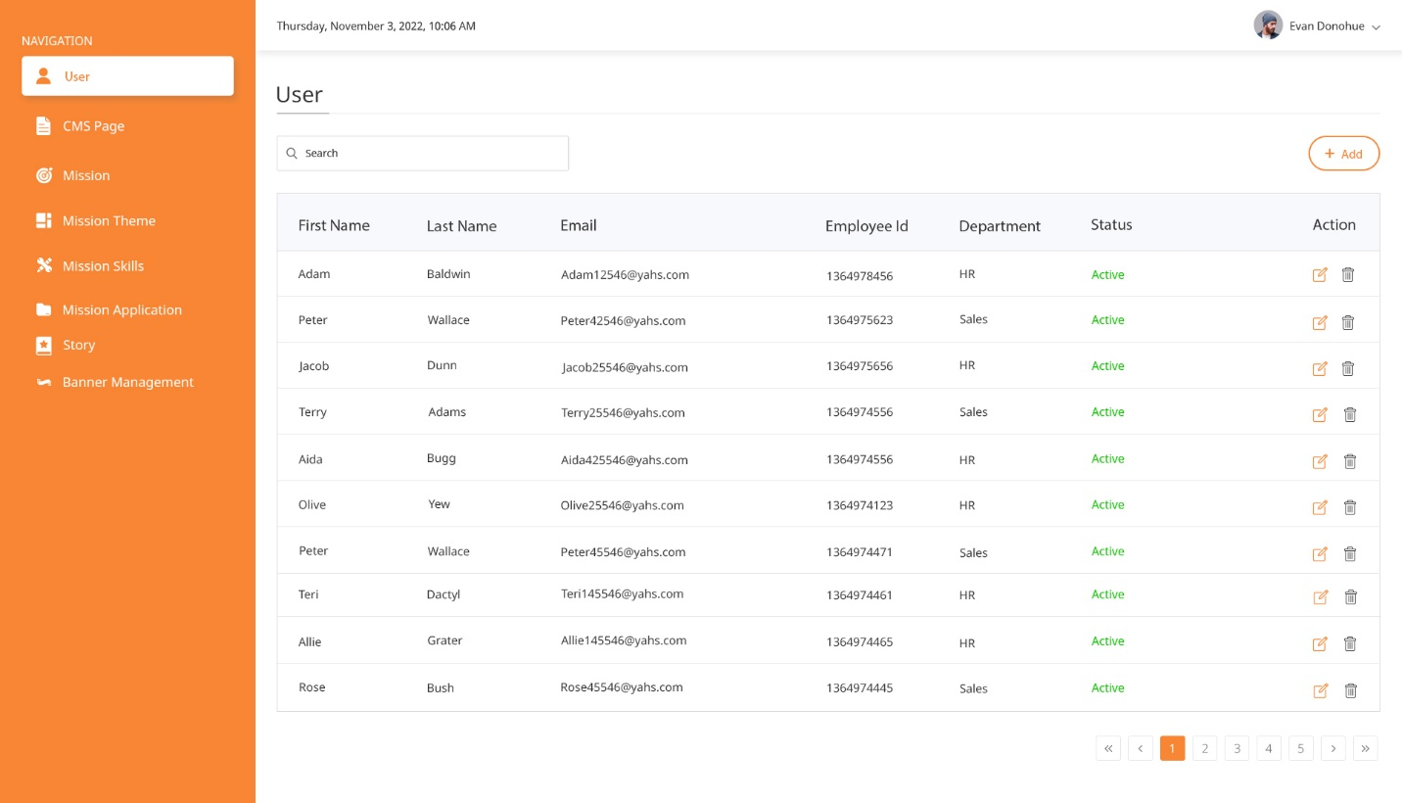

# CMS CRUD

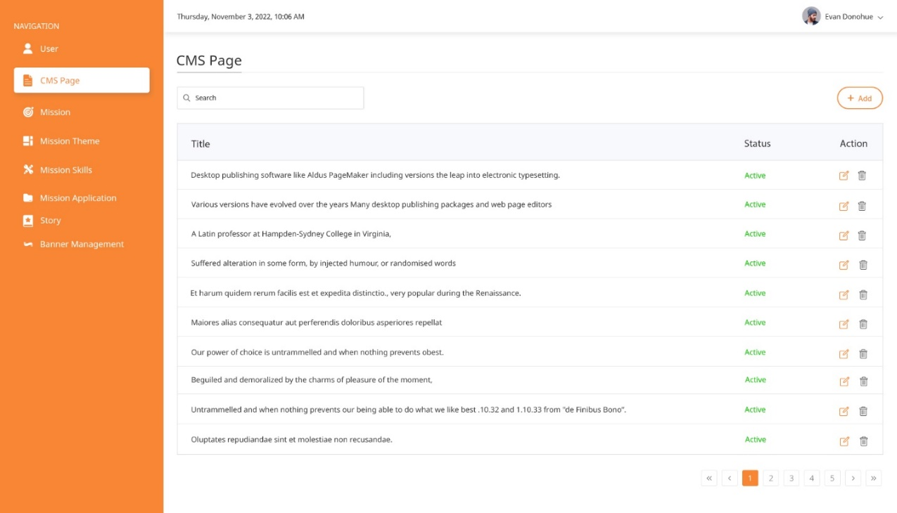

Add

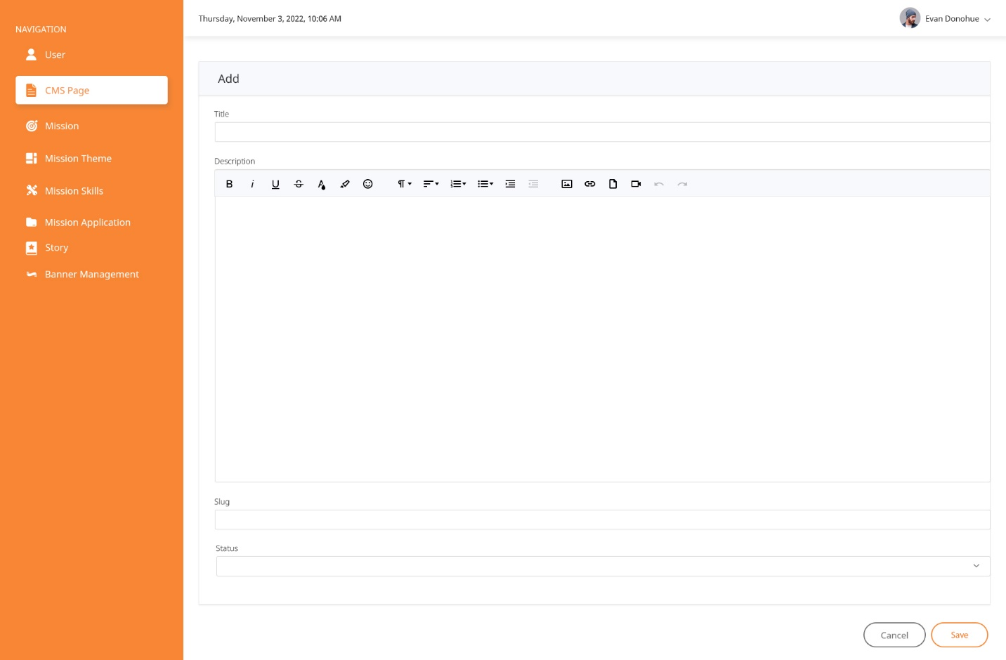

Edit

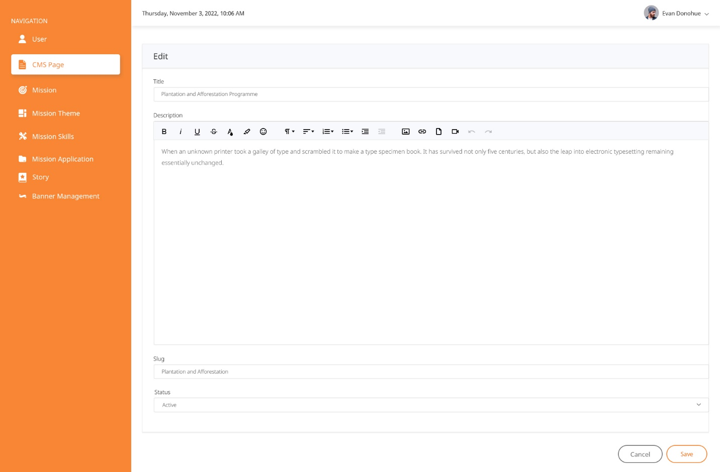

Delete

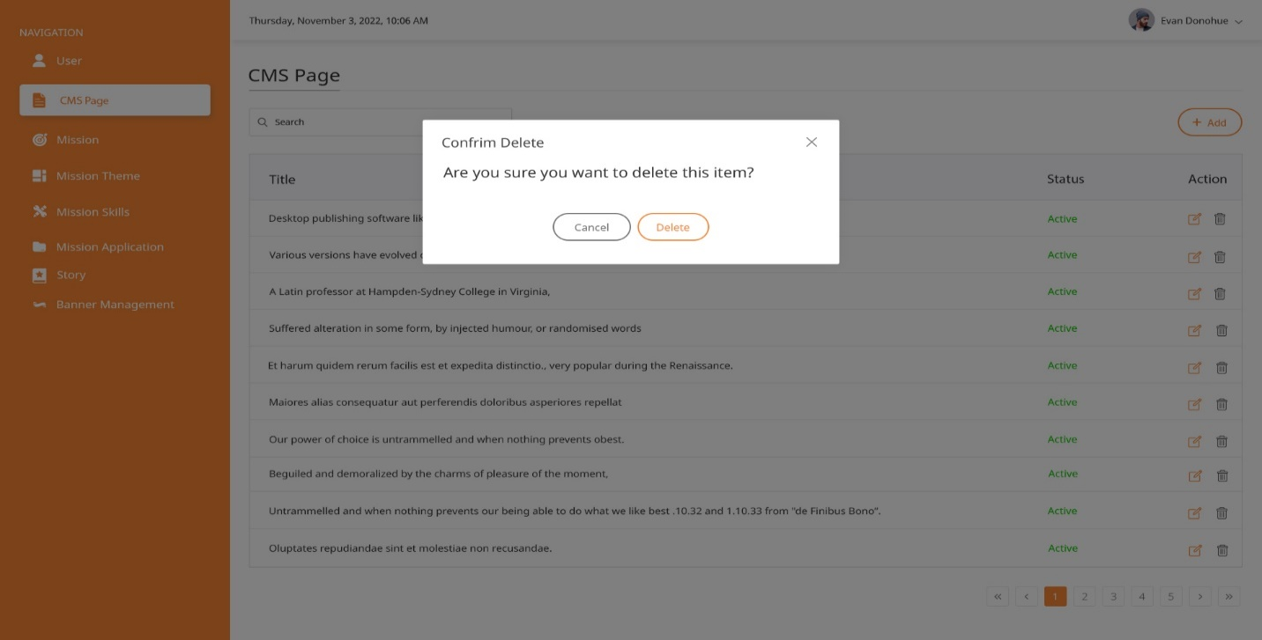

### Mission

Description:

User will be able to submit new mission by clicking on Mission.

Features:

|  |  |  |  |
| --- | --- | --- | --- |
| **#** | **Feature** | **Type** | **Description** |
|  | Country | Drop-down | User can Insert missions by mission Country |
|  | City | Drop-down | User can Insert missions by mission City |
|  | Mission Title | Text | User can Insert missions title |
|  | Mission Description | HTML editor | User can Insert mission description |
|  | Mission Organisation Name | Text | User can Insert mission organisation name |
|  | Mission Organisation Detail | HTML editor | User can Insert mission organisation details |
|  | Mission start date | Datepicker | User can Insert mission start date through date picker |
|  | Mission end date | Datepicker | User can Insert mission end date through date picker |
|  | Total seats | Text | User can Insert total seats |
|  | Mission registration deadline |  | User can Insert mission registration deadline |
|  | Mission Theme | Single select dropdown | User can Insert mission theme |
|  | Mission Skills | Multi select dropdown | User can Insert mission skills |
|  | Mission Images | File | User can Insert mission images |
|  | Mission documents | File | User can Insert mission documents |
|  | Mission Availability | Single select dropdown | User can Insert mission availability |

### D:\Sweety Patel_TSC\2022-2023\Miral-Design\Final-CI-Designs\Mission.jpg

### Mission Application

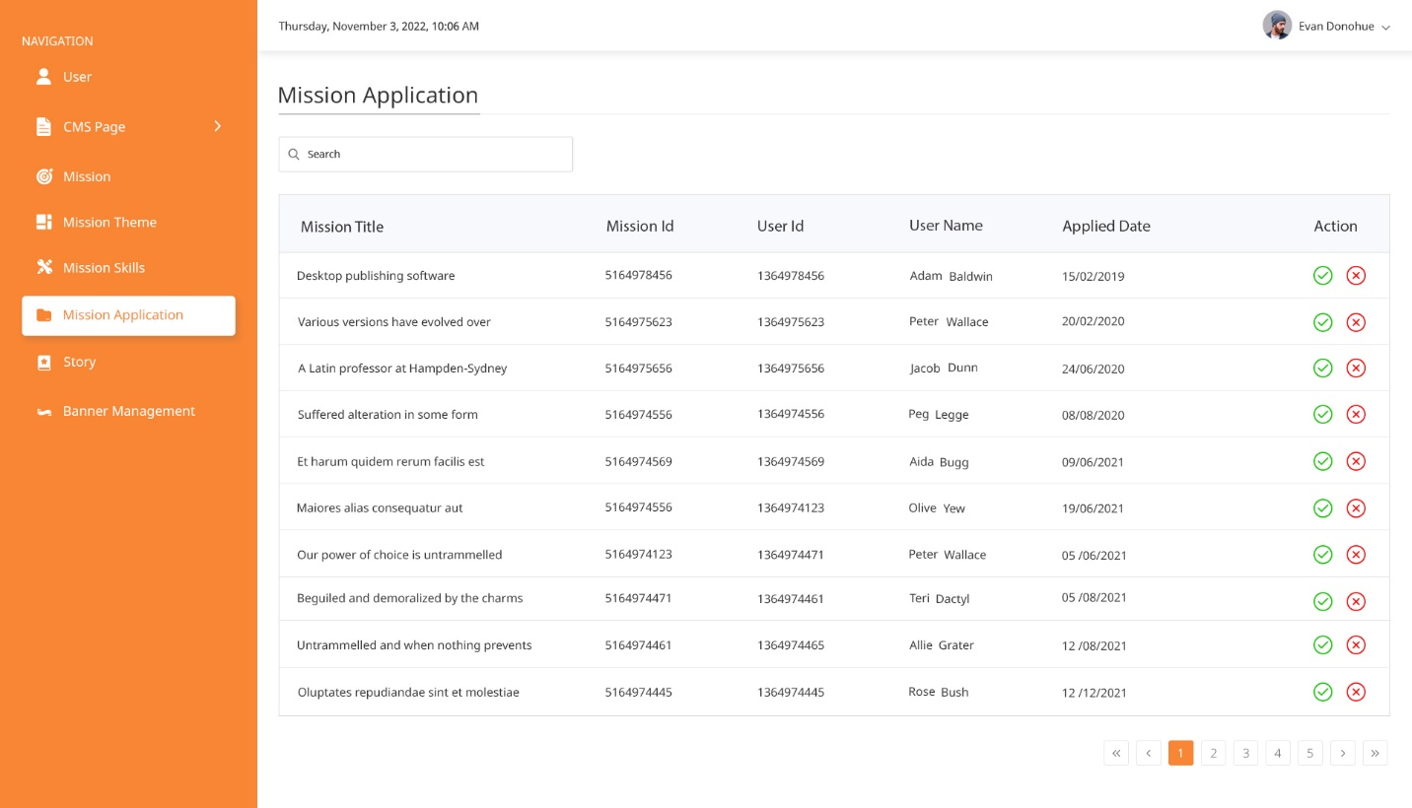

**Story**

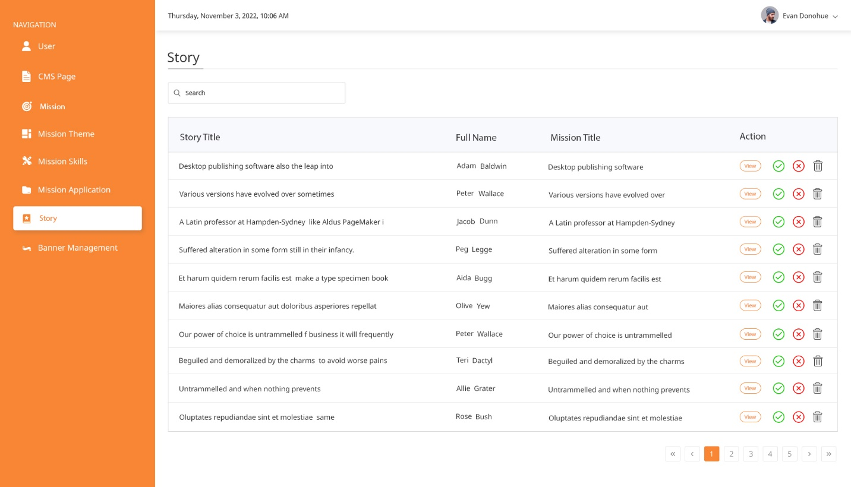

# Technology Stack

Use relevant technologies as per instructions provided:

* Back end: ASP.Net Core API | Node JS | ASP.Net MVC | PHP 7
* Front end: React JS | Angular 11+ | Vue JS | ASP.Net MVC | PHP 7
* Database: SQL Server 2017 | Mongo | Postgres | My SQL
* Tools/IDE: Visual Studio 2019 | Visual Studio Code
* Source Control Repository: GitHub
* ORM: Entity Framework | Sequalize

Thank you